ewsOverview of Spring Applications:

* Spring Beans & Annotations:
* Spring Scopes:
* Spring Auto-wiring and Dependency Injections
* Spring MVC-Application sample

<https://www.javatpoint.com/spring-tutorial>

**Introduction to SpringBoot**

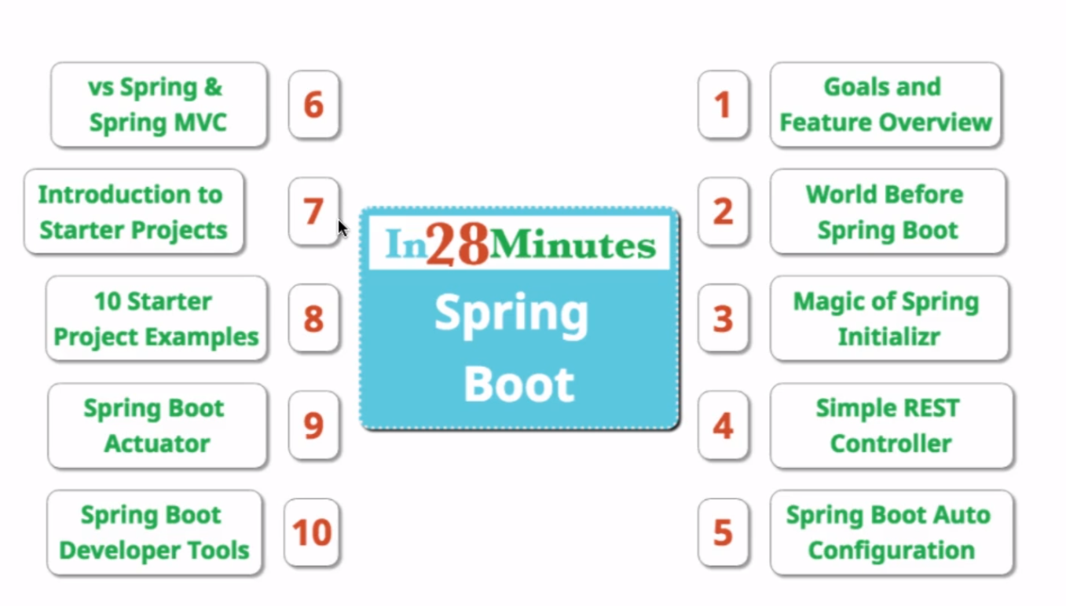

**Introduction to Spring Boot - Goals and Important  
Features**

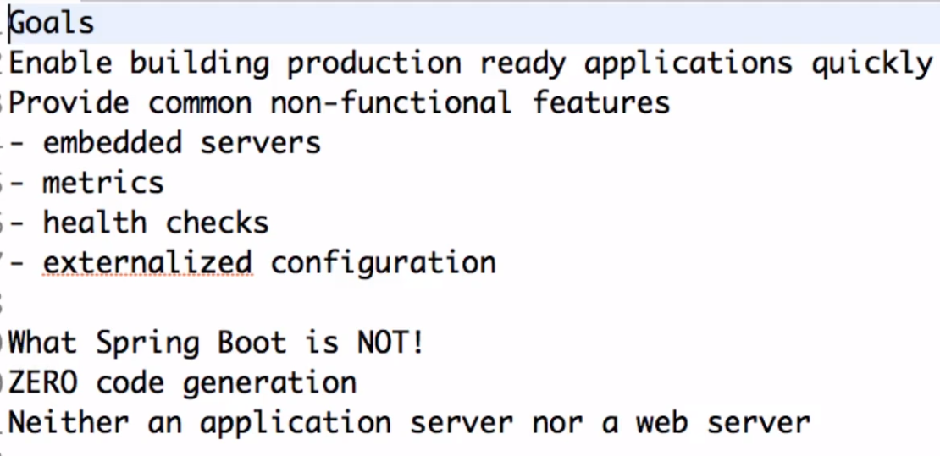

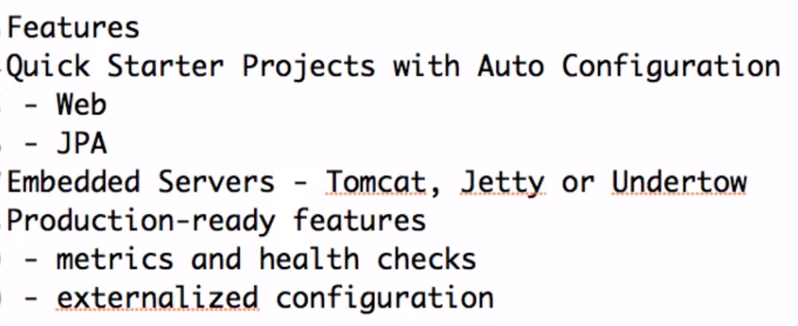

**Developing Spring Applications before Spring Boot**

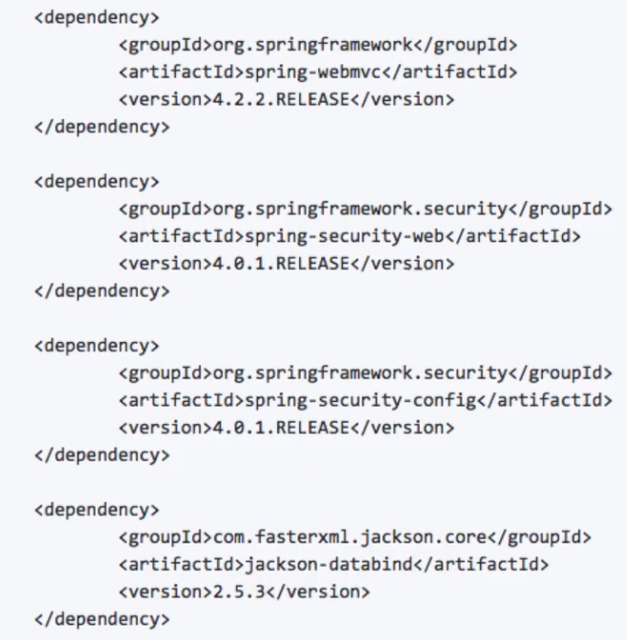

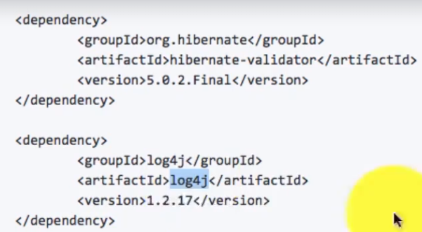

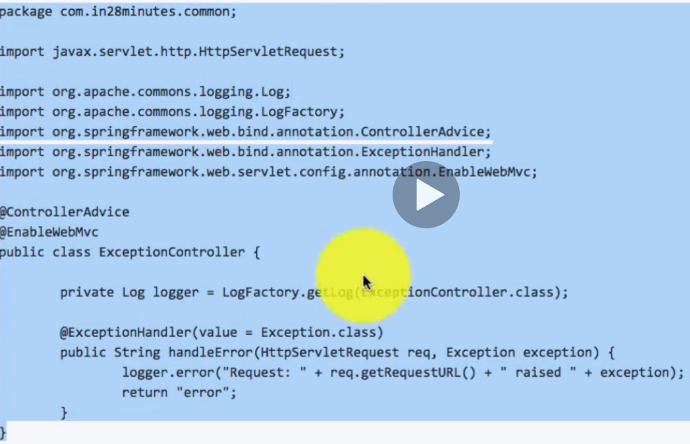

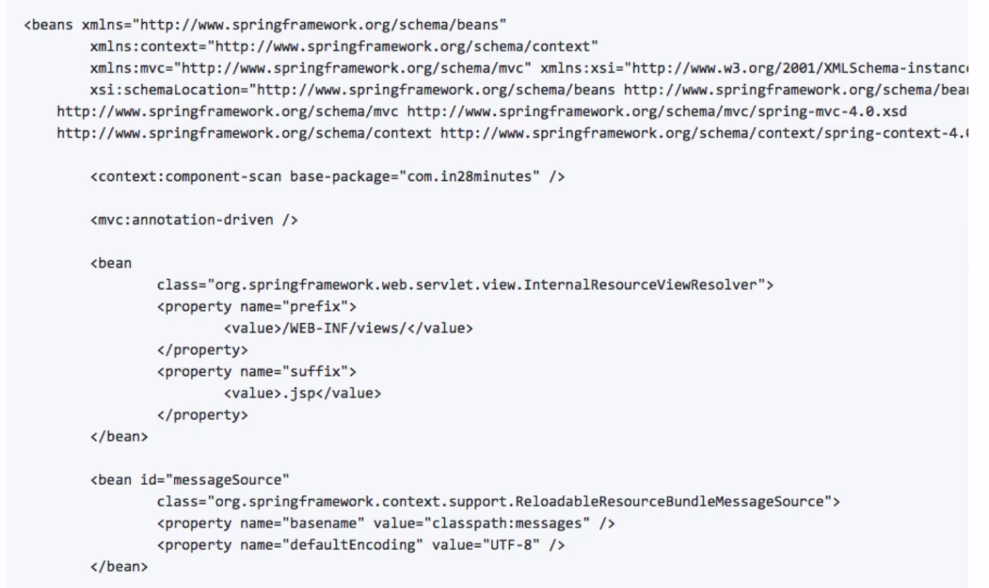

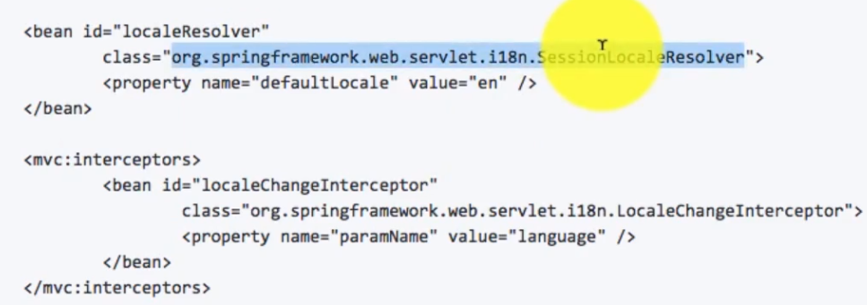

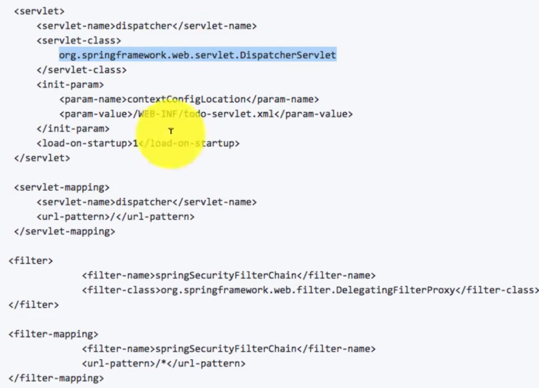

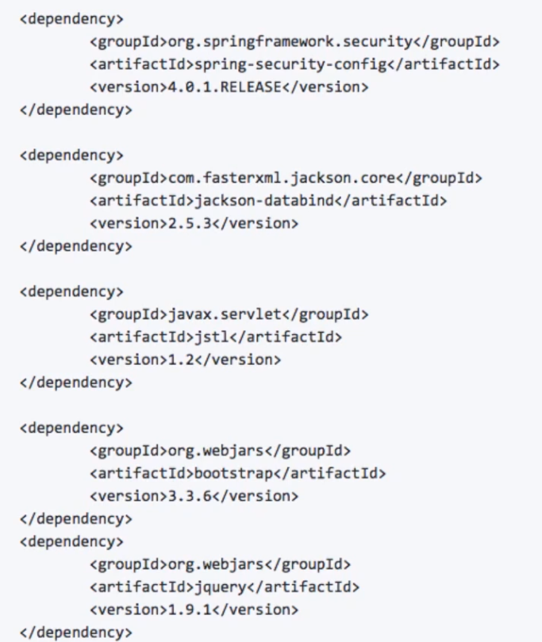

**Using Spring Initializer to create a project**

<https://start.spring.io/>

**Creating a Simple REST Controller**

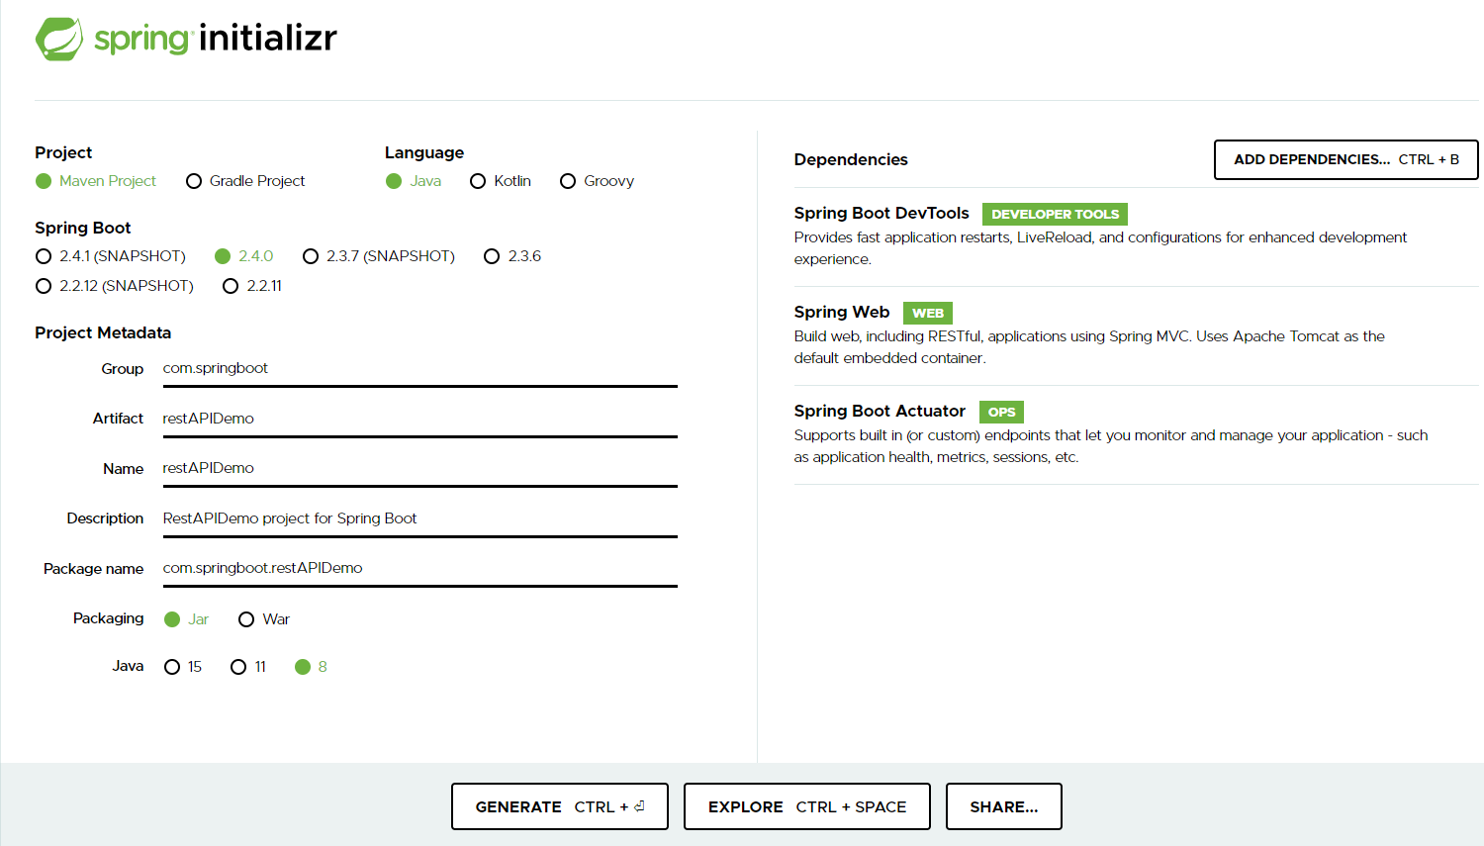

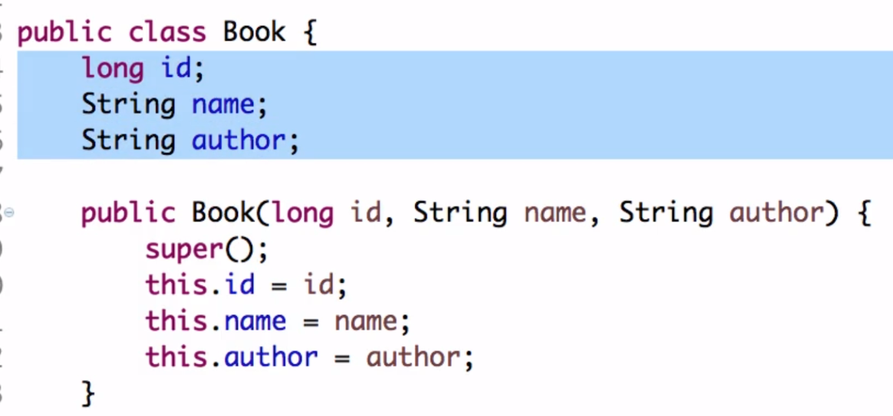

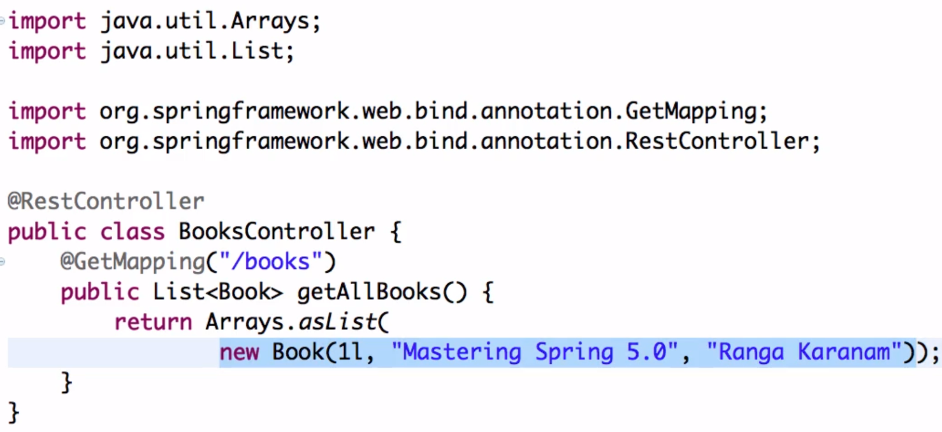

**What isBoot Auto Configuration?**

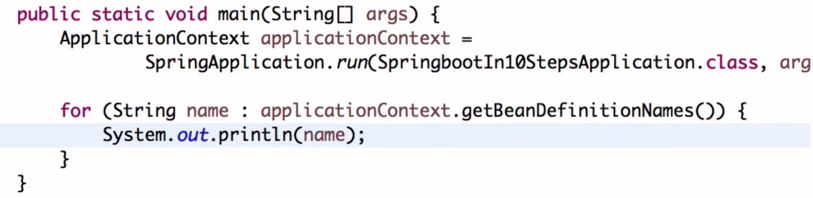

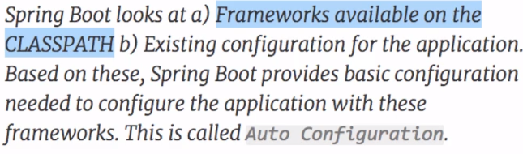

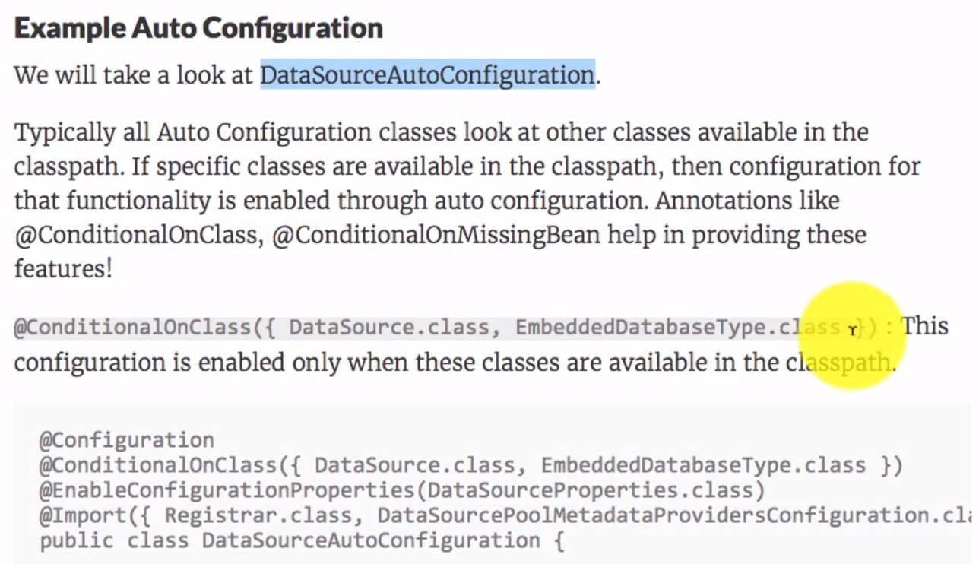

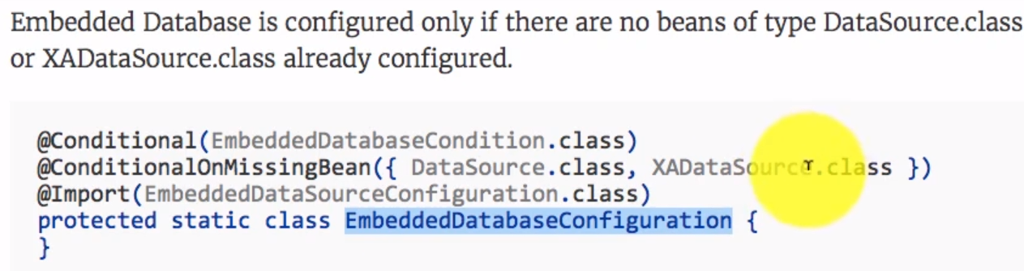



**Spring Boot vs Spring vs Spring MVC**

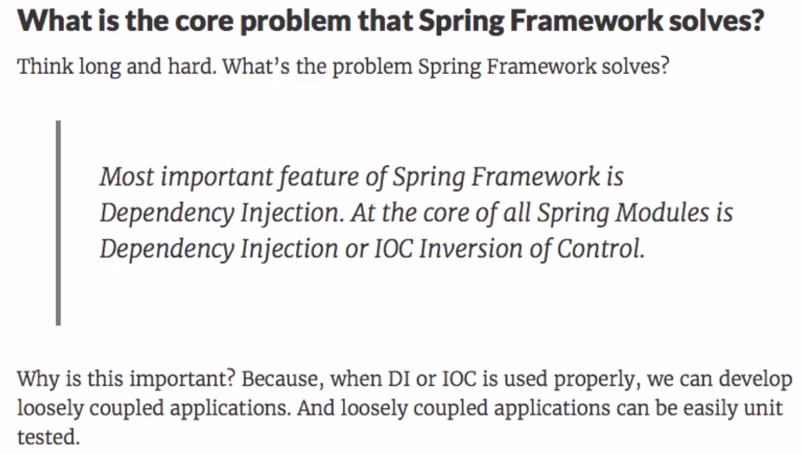

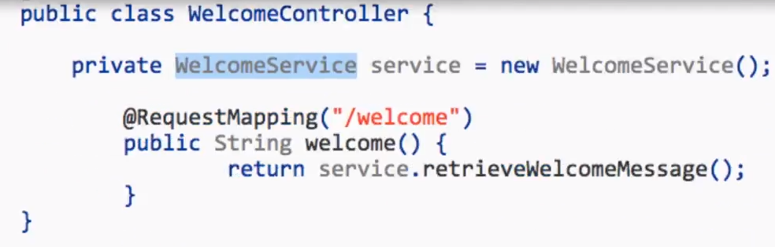

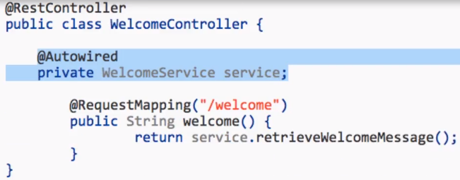

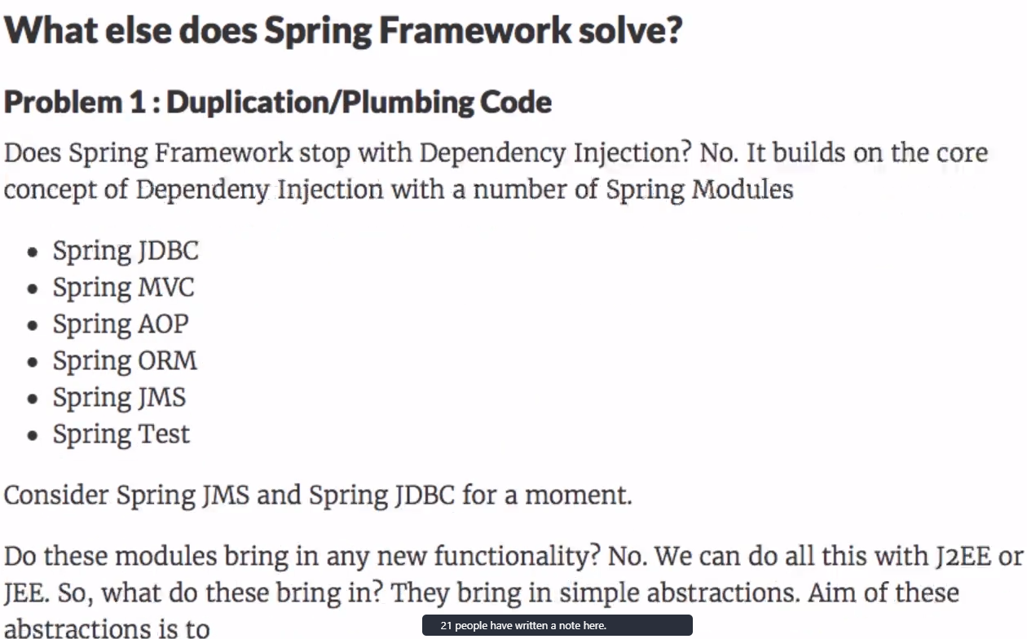

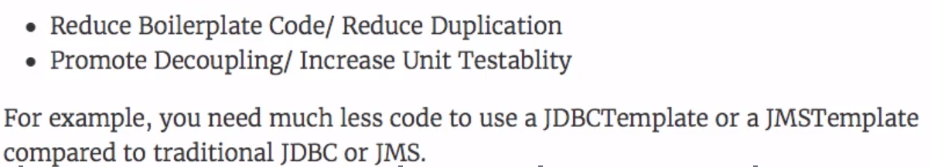

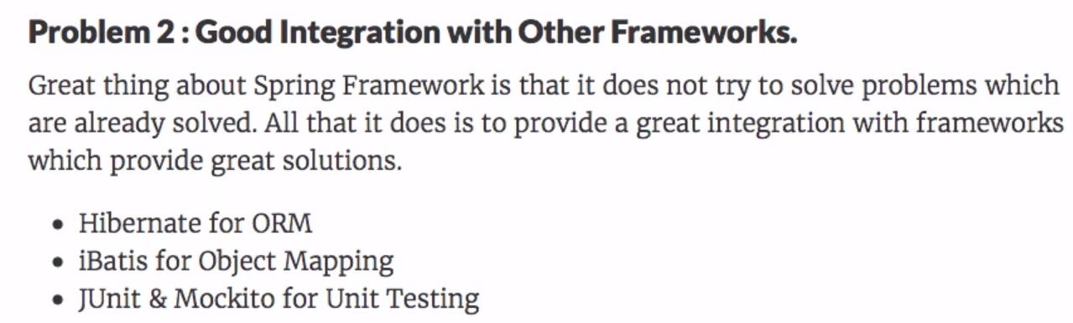

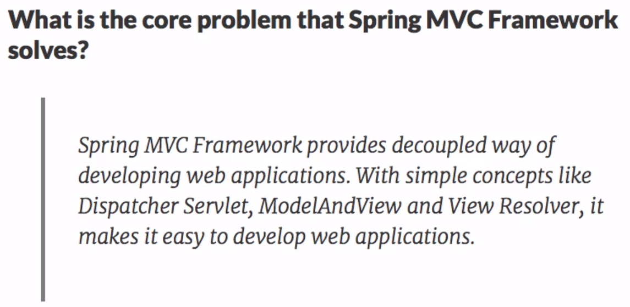

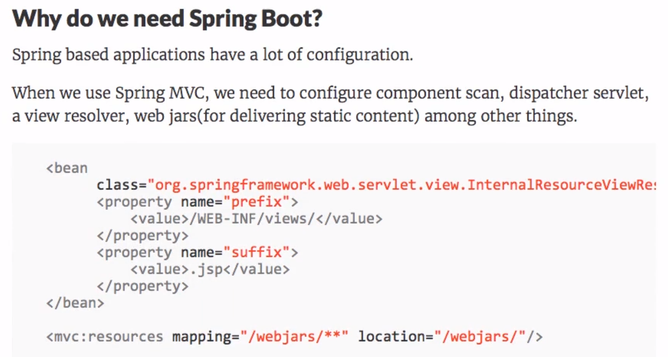

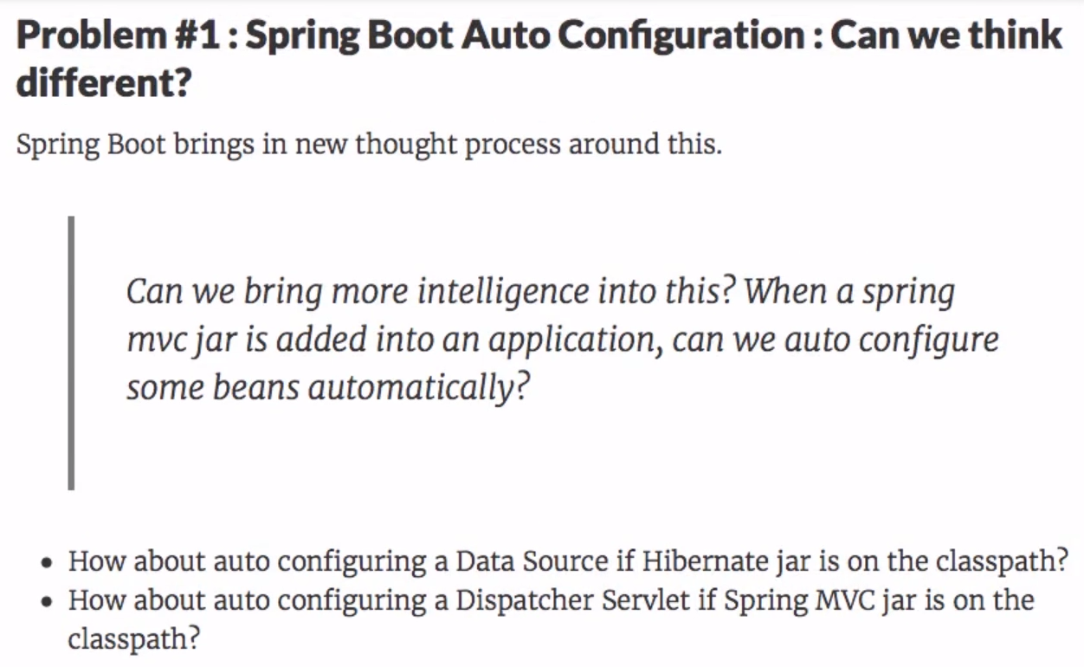

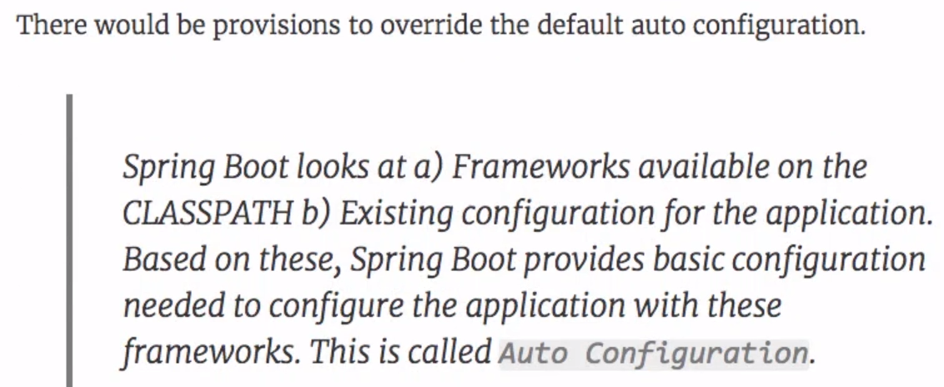

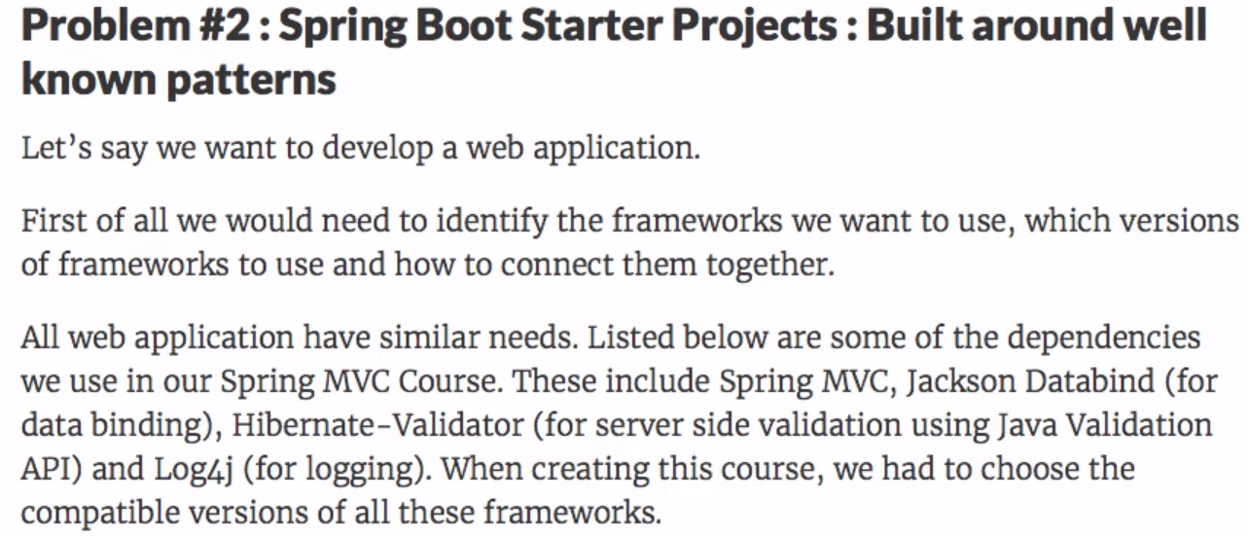

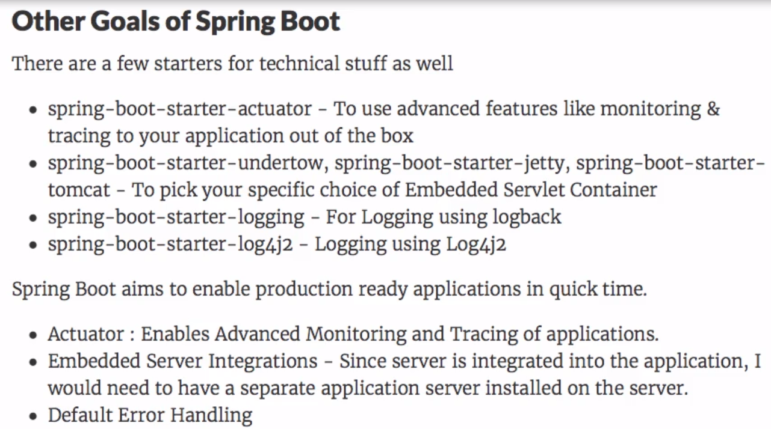

**Spring Boot Starter Projects - Starter Web and  
Starter JPA**

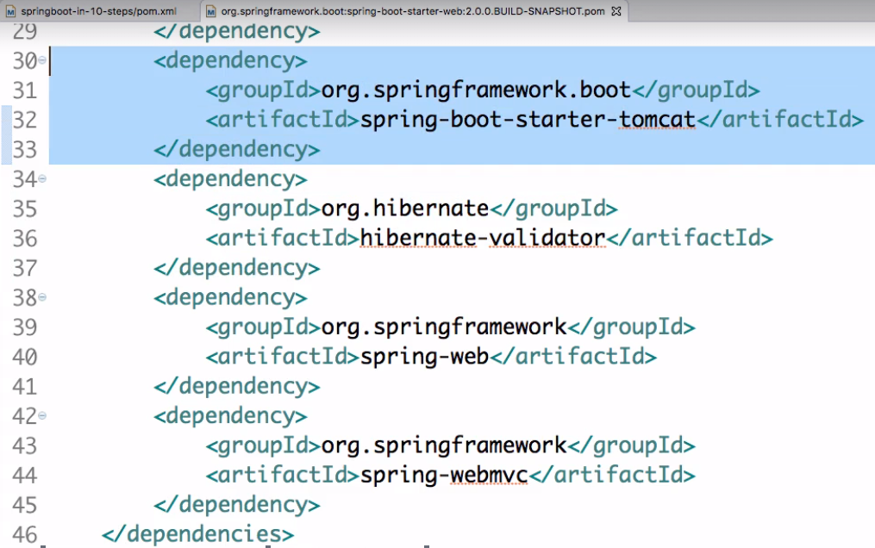

**Overview of different Spring Boot Starter Projects**

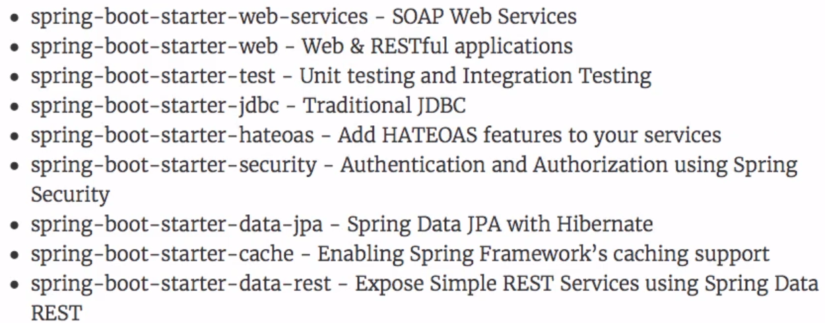

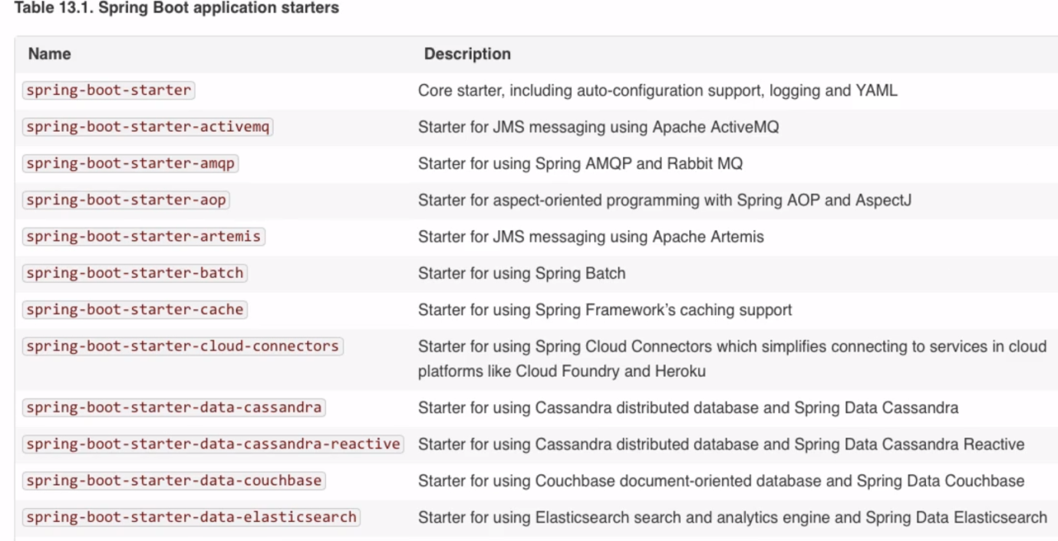

**Spring Boot Actuator**

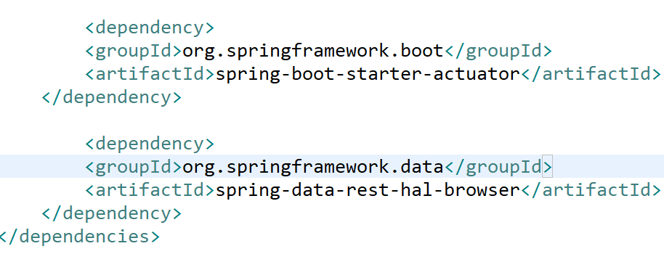



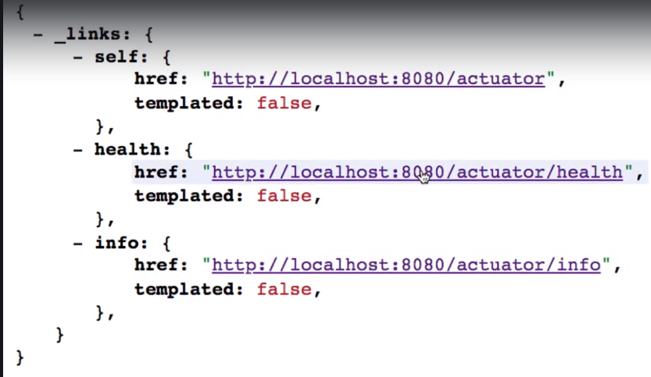



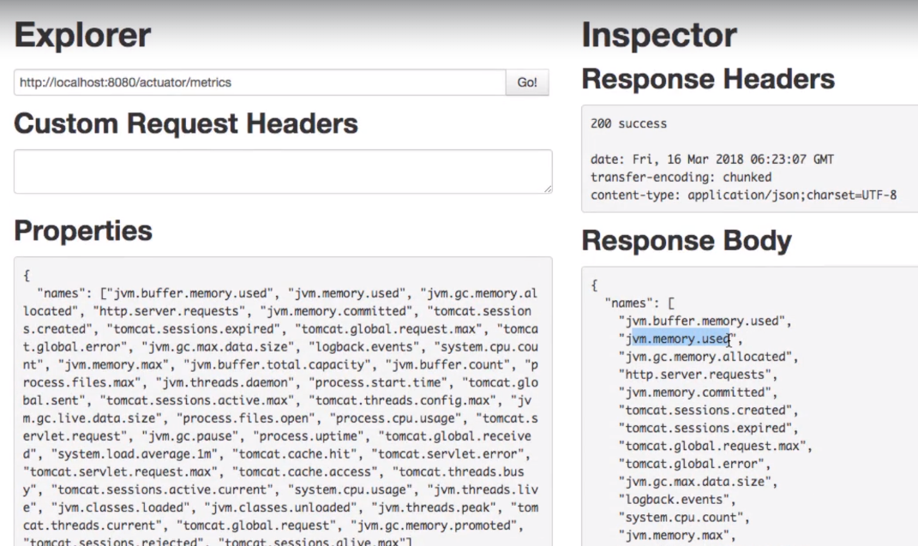

**Spring Boot Developer Tools**

Instant Restart if any changes.

Also takes less time compared to the initial start.

**18th August 2020:**

* Step 04 - Enhancing the Hello World Service to return a Bean
* Step 05 - Quick Review of Spring Boot Auto Configuration and Dispatcher Servlet - What's happening in the background?
* Step 06 - Enhancing the Hello World Service with a Path Variable

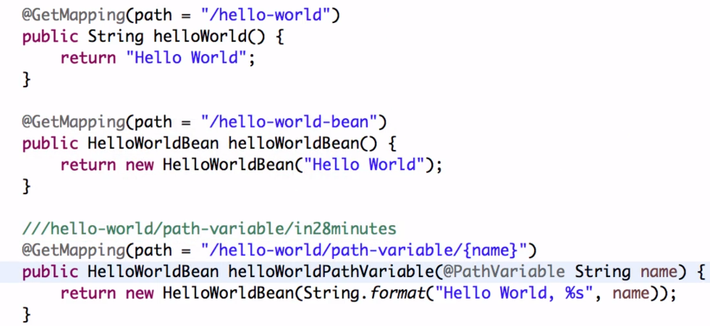

* Step 07 - Creating User Bean and User Service

Bean -> Service ->Dao

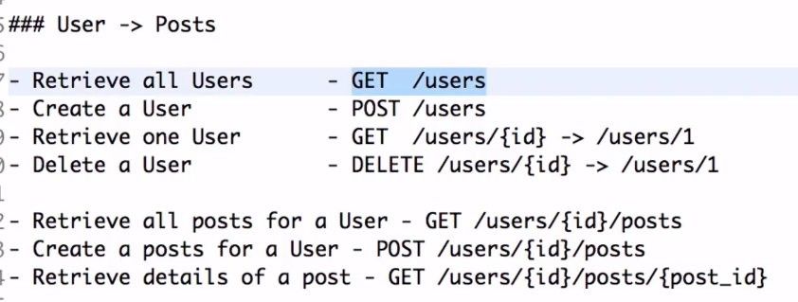

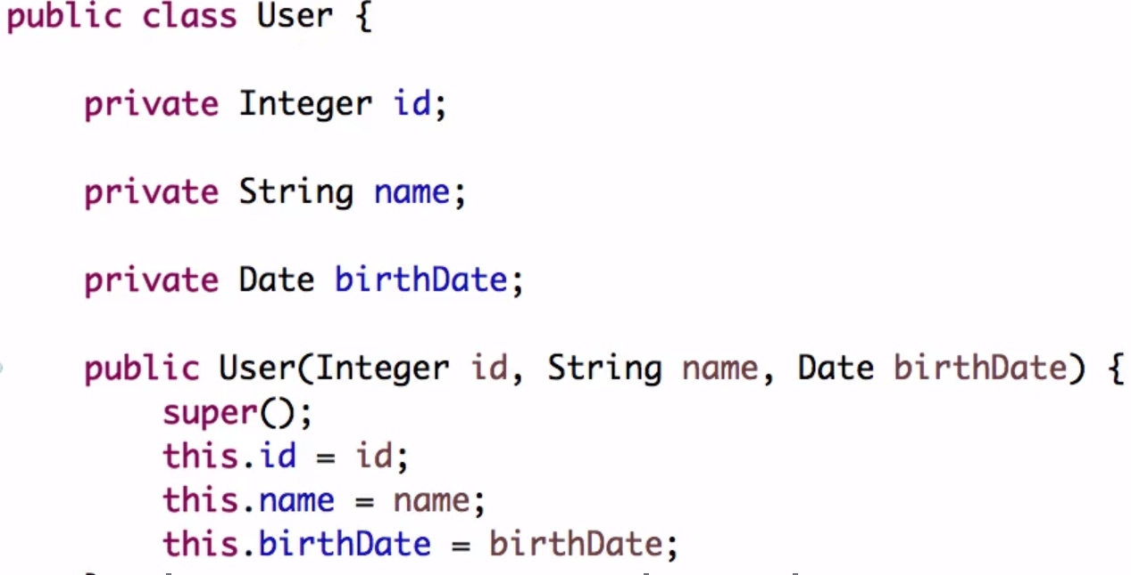

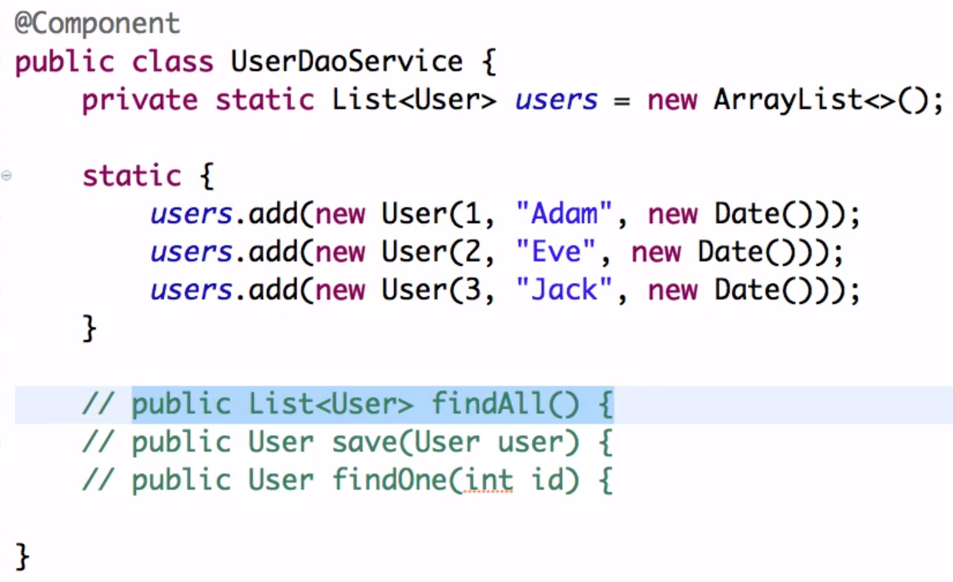

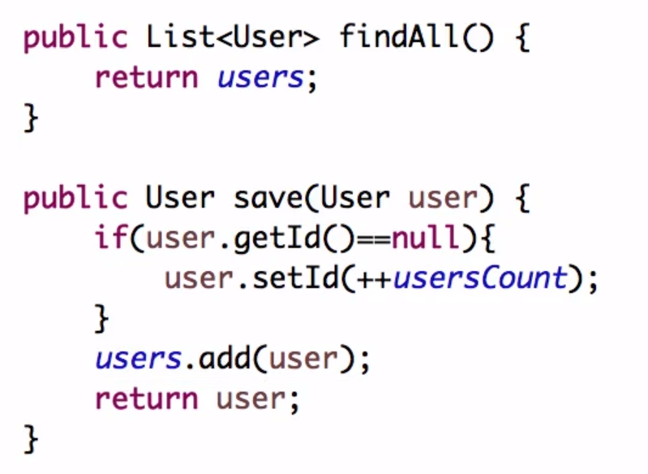

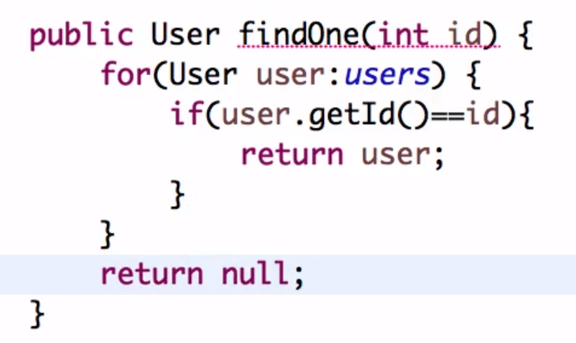

* Step 08 - Implementing GET Methods for User Resource

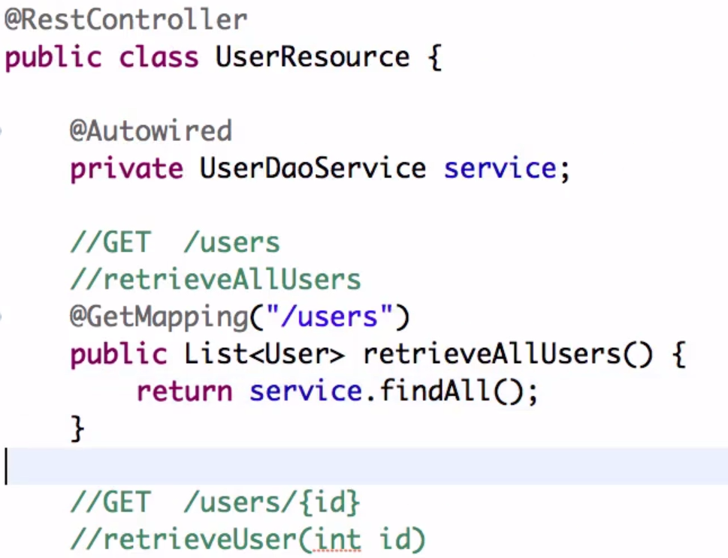



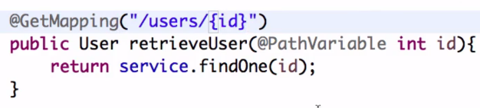

* Step 09 - Implementing POST Method to create User Resource

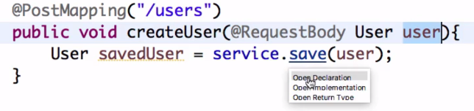

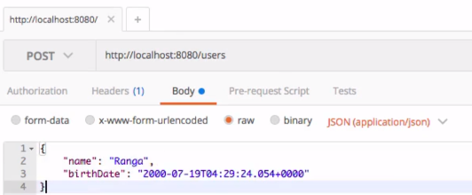

Step 10 - Enhancing POST Method to return correct HTTP Status Code and Location

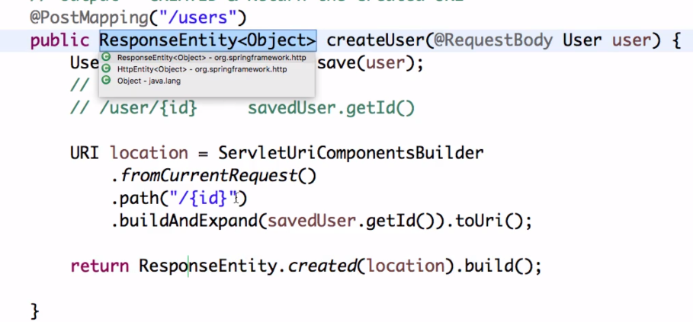

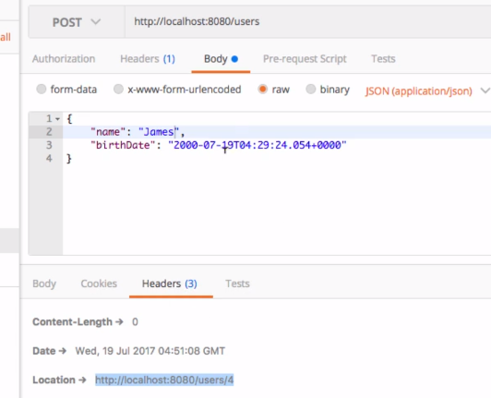

Step 11 - Implementing Exception Handling - 404 Resource Not Found

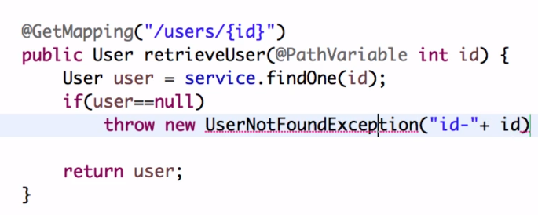

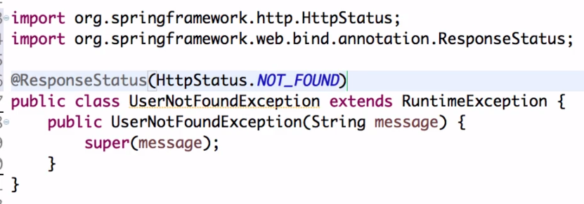

Step 12 - Implementing Generic Exception Handling for all Resources

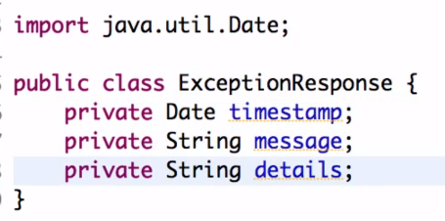

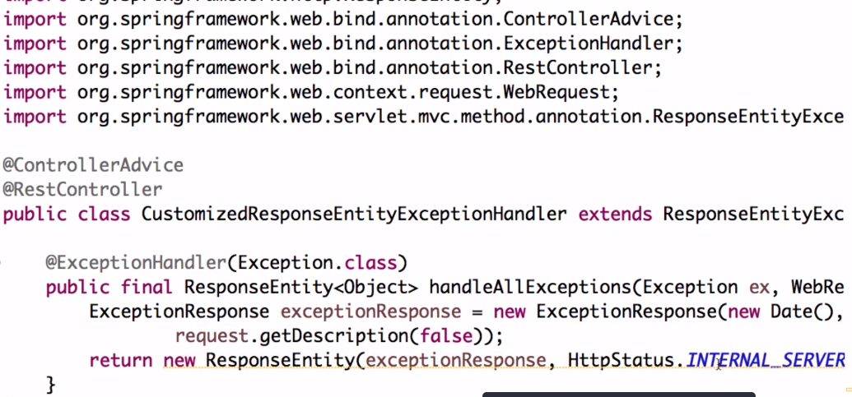

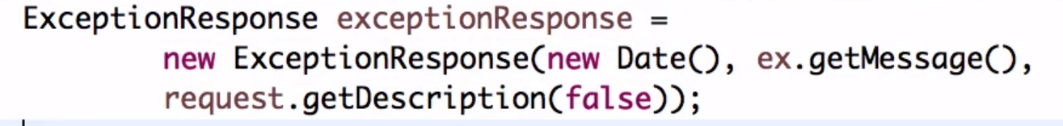

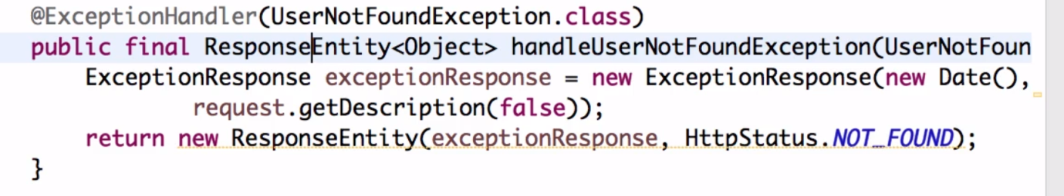

Step 13 - Exercise : User Post Resource and Exception

Handling

Step 14 - Implementing DELETE Method to delete a User  
Resource

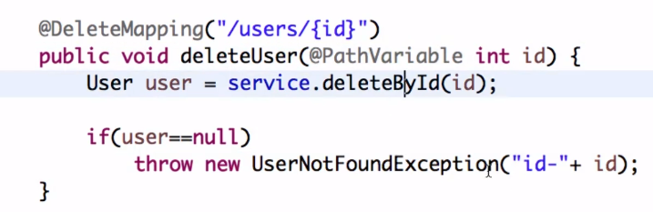

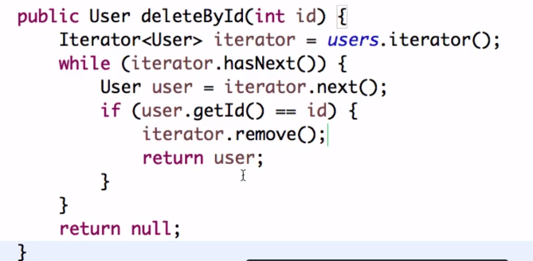

.

Step 15 - Implementing Validations for RESTful Services

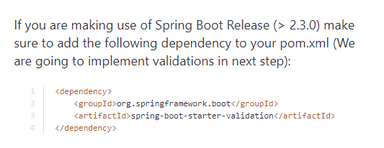

Add @Valid annotation on the createUser method

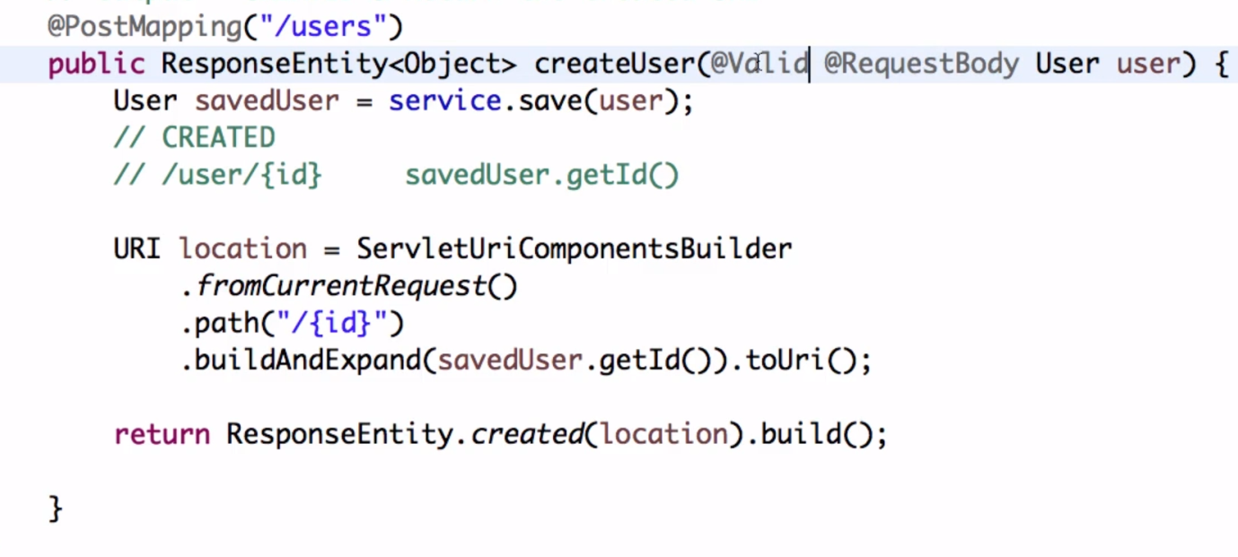

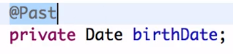

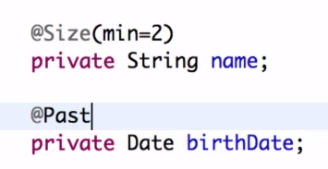

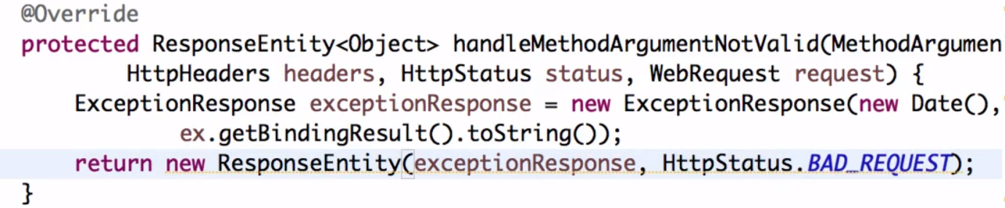

Replace ex.getMessage with Validation Failed

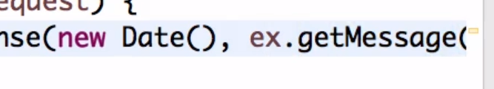

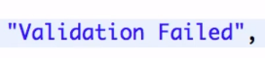

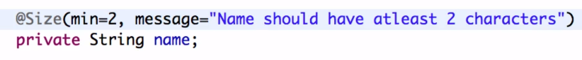

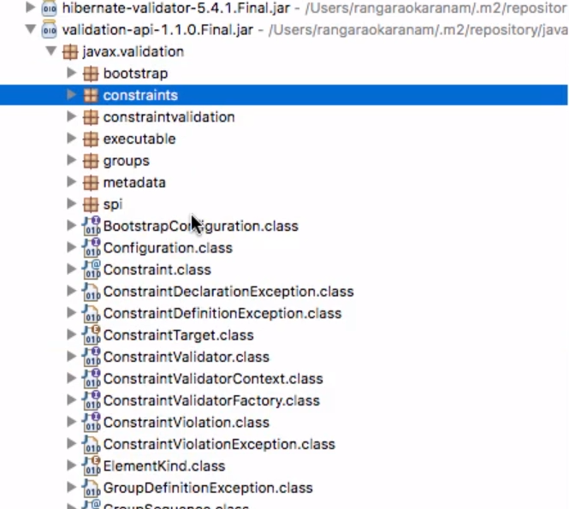

**HATEOS: (Hypermedia As The Engine Of ApplicationState)**

Step 16 - Implementing HATEOAS for RESTful Services

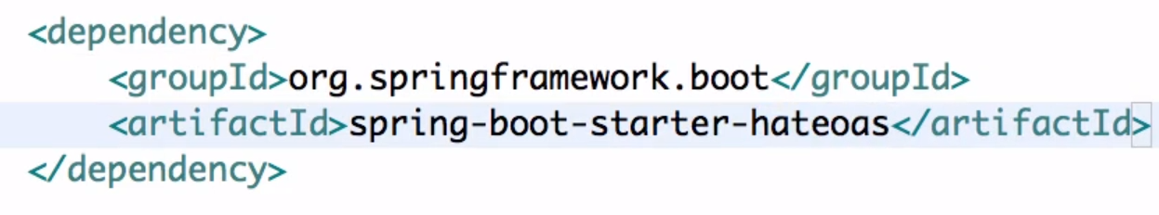



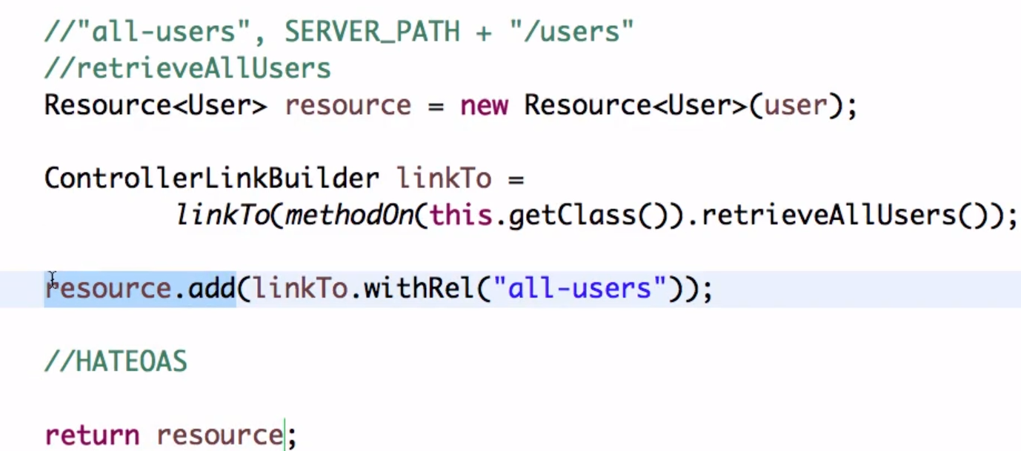

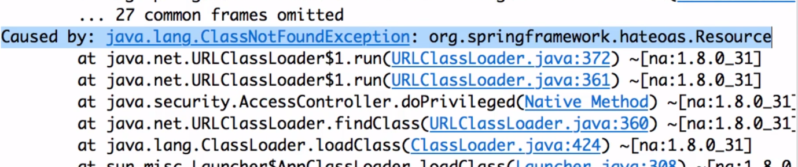

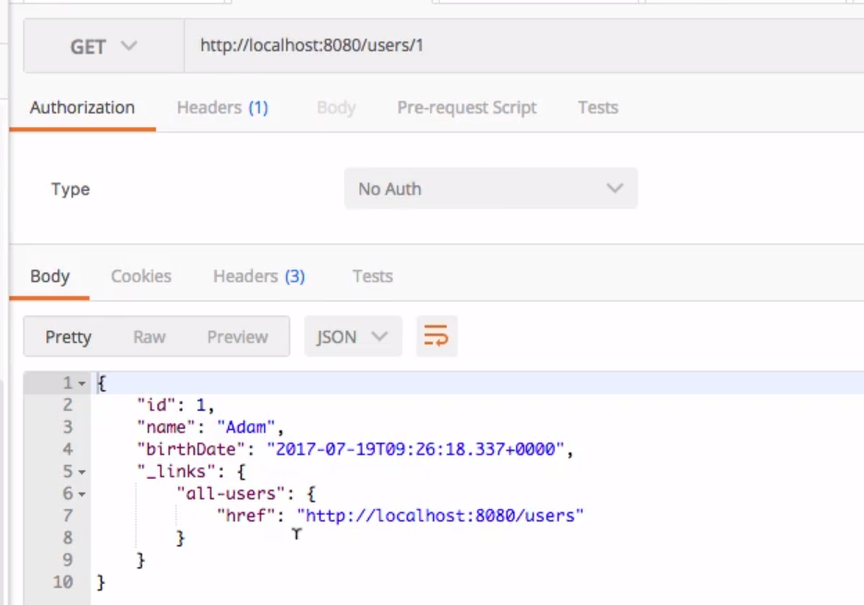

Step 18 - Internationalization for RESTful Services(I18N)

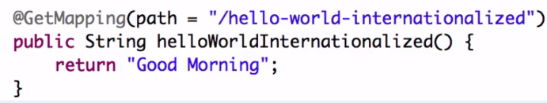

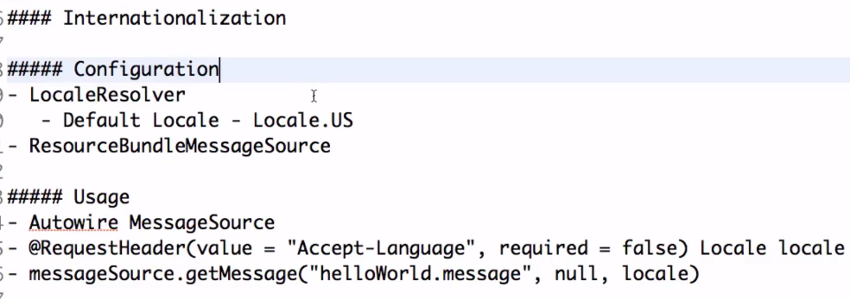

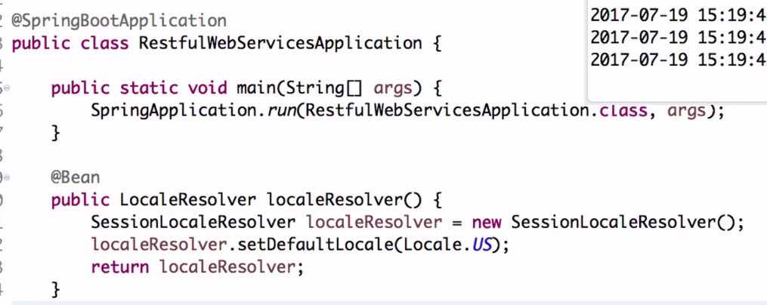

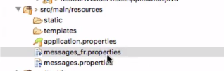



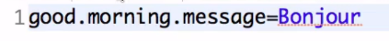

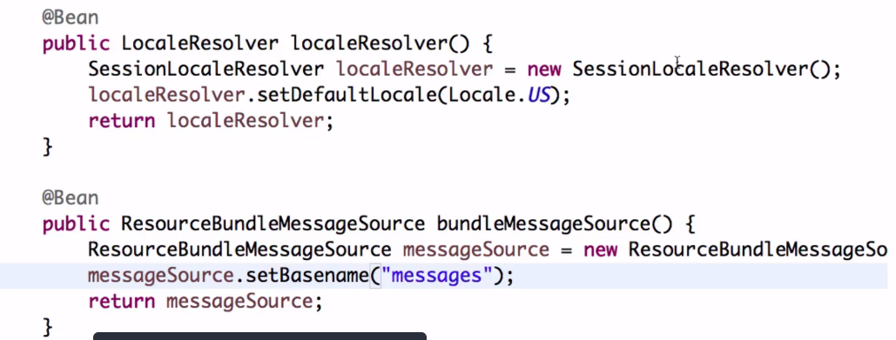

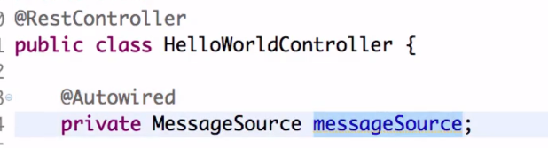

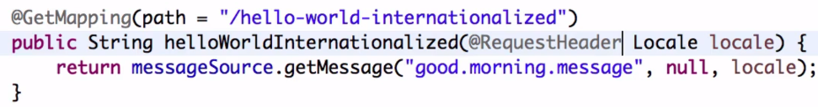



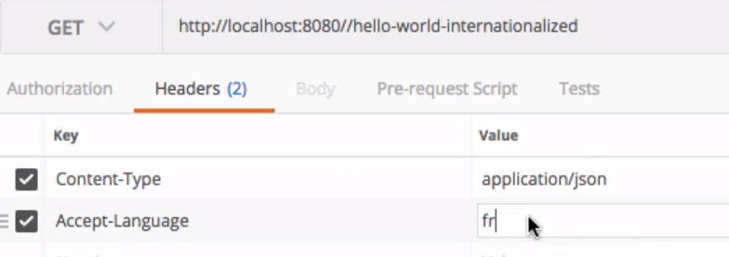

Step 18 Part 2 - Internationalization for RESTful Services

**OLD:**

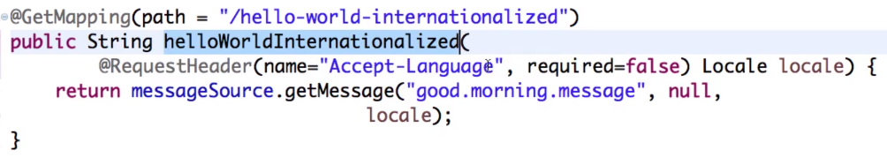

**NEW:**

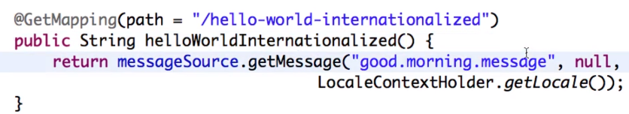

**OLD:**

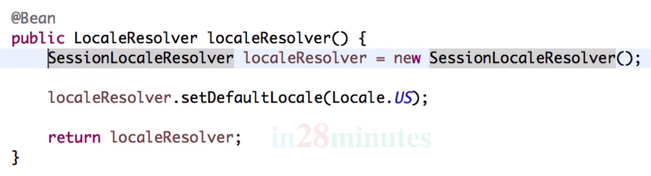

**NEW:**

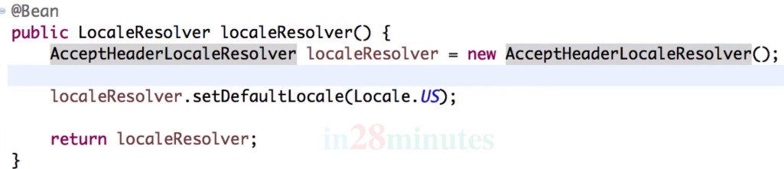

**OLD:**

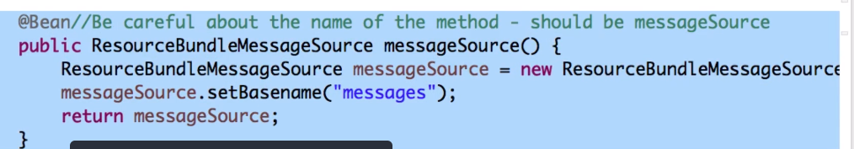

**NEW:**

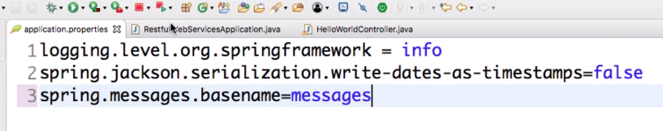

Remove the OLD code